Tetrahedron
# Source: AI Source: Provided by: [Data Path: Persons Table -> ID Column: 1, Name_En Column: Motasem Essam] -> From: [ChatGPT] on [7/25/2026]
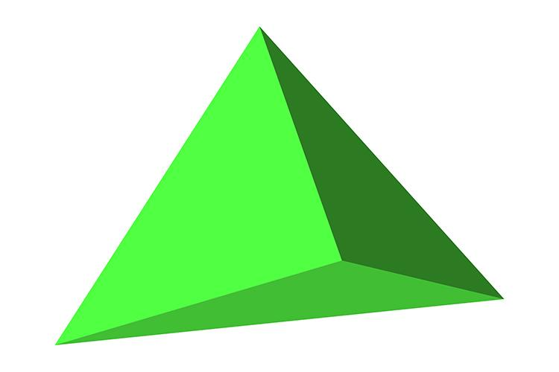
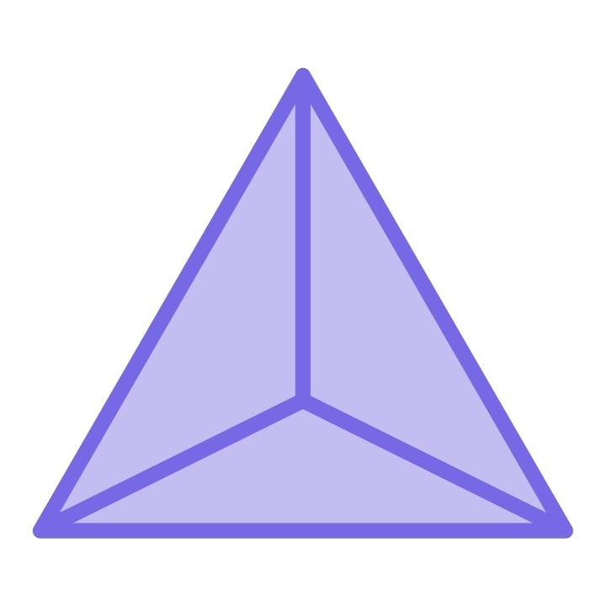
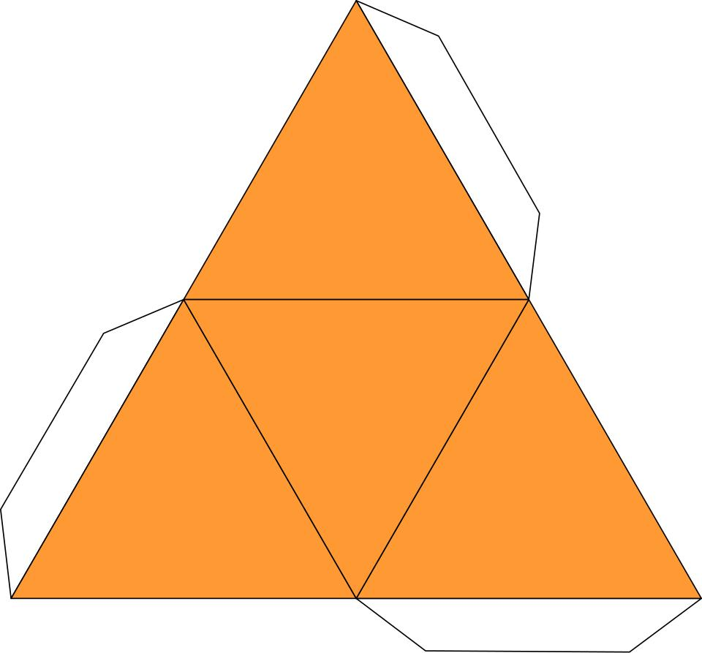

Definition
# Source: AI Source: Provided by: [Data Path: Persons Table -> ID Column: 1, Name_En Column: Motasem Essam] -> From: [ChatGPT] on [7/25/2026]
A tetrahedron is a polyhedron with exactly four triangular faces, six edges, and four vertices. It is one of the five Platonic solids when all four faces are congruent equilateral triangles.
The regular tetrahedron is the simplest of the five Platonic solids. Every face is an equilateral triangle, every edge has the same length, and the same number of faces meet at each vertex.
The word tetrahedron comes from Greek: tetra means four, and hedra means face.

Simple Definition
# Source: AI Source: Provided by: [Data Path: Persons Table -> ID Column: 1, Name_En Column: Motasem Essam] -> From: [ChatGPT] on [7/25/2026]
A tetrahedron is a three-dimensional solid shaped like a triangular pyramid with four triangular faces.
- Faces: 4 triangles
- Edges: 6 line segments
- Vertices: 4 corners
A regular tetrahedron has four identical equilateral-triangle faces.

Key Characteristics
# Source: AI Source: Provided by: [Data Path: Persons Table -> ID Column: 1, Name_En Column: Motasem Essam] -> From: [ChatGPT] on [7/25/2026]
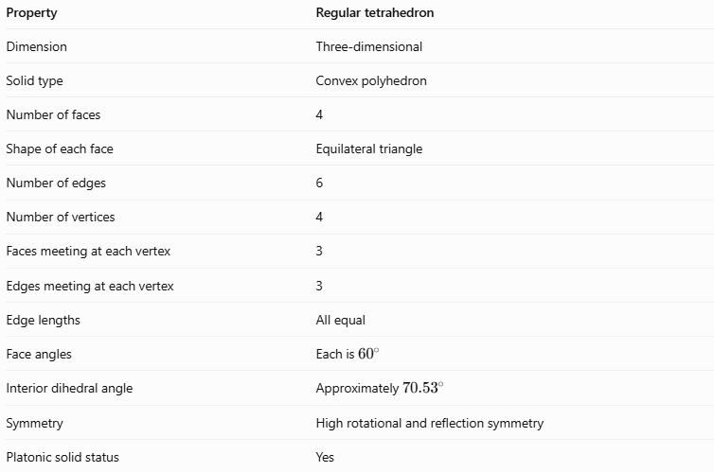
Property | Regular tetrahedron
Dimension | Three-dimensional
Solid type | Convex polyhedron
Number of faces | 4
Shape of each face | Equilateral triangle
Number of edges | 6
Number of vertices | 4
Faces meeting at each vertex | 3
Edges meeting at each vertex | 3
Edge lengths | All equal
Face angles | Each is \(60^\circ\)
Interior dihedral angle | Approximately \(70.53^\circ\)
Symmetry | High rotational and reflection symmetry
Platonic solid status | Yes

Geometric Representation
# Source: AI Source: Provided by: [Data Path: Persons Table -> ID Column: 1, Name_En Column: Motasem Essam] -> From: [ChatGPT] on [7/25/2026]
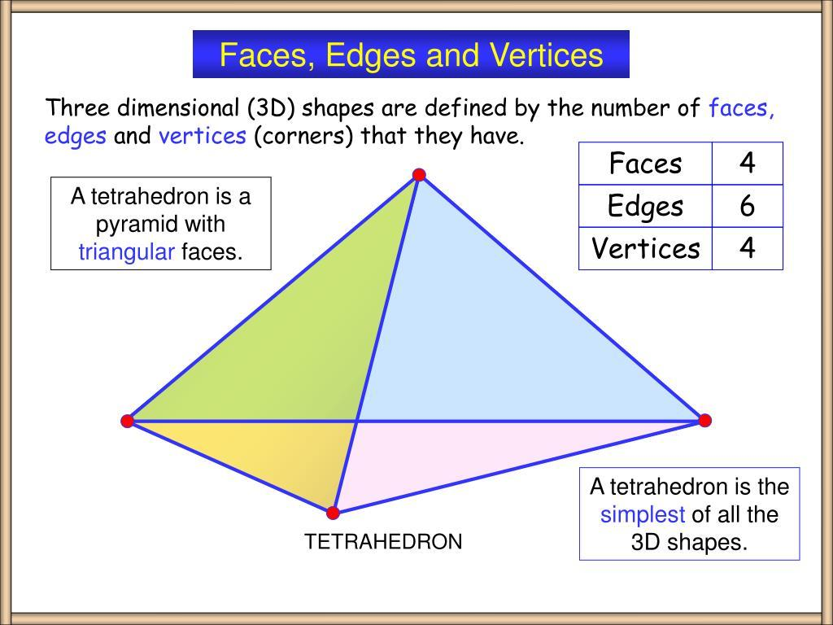
A tetrahedron can be described using four vertices, labeled $A$, $B$, $C$, and $D$.
Its four triangular faces are:
- $△ABC$
- $△ABD$
- $△ACD$
- $△BCD$
Its six edges are:
- $AB$, $AC$, $AD$
- $BC$, $BD$, $CD$
Every pair of distinct vertices is connected by an edge. In a regular tetrahedron, all six edges have the same length.
Faces, edges, and vertices
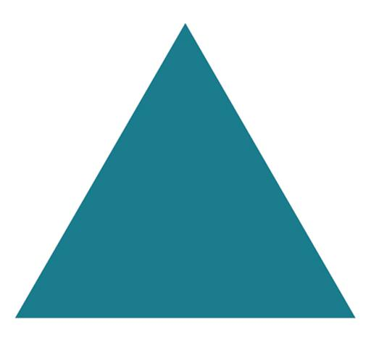
Faces
The four flat surfaces are equilateral triangles. Each face has three equal sides and three ${60}^{∘}$ angles.
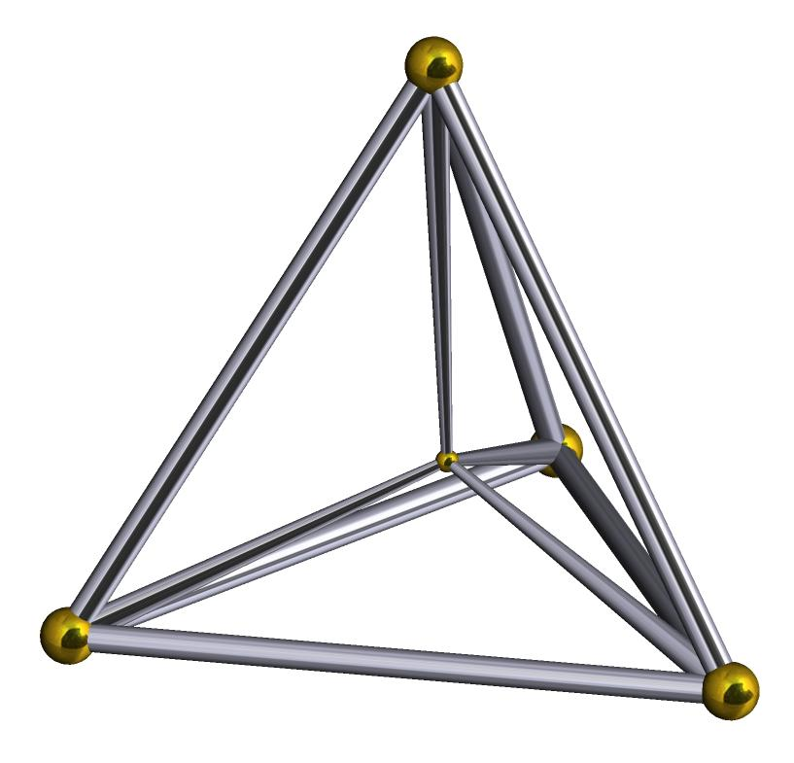
Edges
The six straight line segments form the boundaries of the triangular faces. Each edge belongs to exactly two faces.
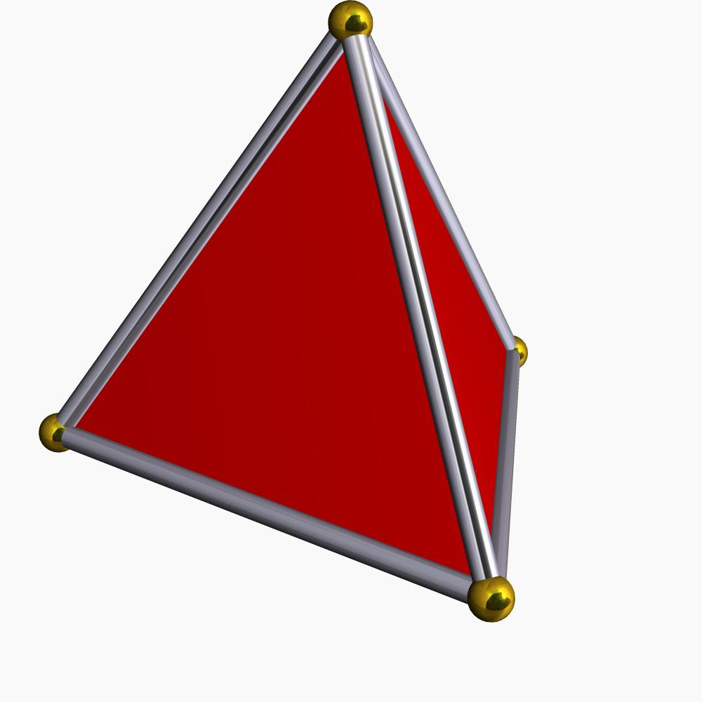
Vertices
The four corners are the points where three edges and three faces meet.

Mathematical Representations and Formulas
# Source: AI Source: Provided by: [Data Path: Persons Table -> ID Column: 1, Name_En Column: Motasem Essam] -> From: [ChatGPT] on [7/25/2026]
Let:
- $a$ = edge length
- $h$ = perpendicular height
- $B$ = area of the triangular base
- $A_{T}$ = total surface area
- $V$ = volume

Number of faces, edges, and vertices
# Source: AI Source: Provided by: [Data Path: Persons Table -> ID Column: 1, Name_En Column: Motasem Essam] -> From: [ChatGPT] on [7/25/2026]
For a tetrahedron:
$$F=4, E=6, V_{e}=4$$
Euler's formula for convex polyhedra is:
$$V_{e}-E+F=2$$
Substituting the tetrahedron's values:
$$4-6+4=2$$
Therefore, the tetrahedron satisfies Euler's formula.

Area of one face
# Source: AI Source: Provided by: [Data Path: Persons Table -> ID Column: 1, Name_En Column: Motasem Essam] -> From: [ChatGPT] on [7/25/2026]
Each face is an equilateral triangle with side length $a$.
$$A_{f}=\frac{\sqrt{3}}{4}a^{2}$$

Total surface area
# Source: AI Source: Provided by: [Data Path: Persons Table -> ID Column: 1, Name_En Column: Motasem Essam] -> From: [ChatGPT] on [7/25/2026]
A regular tetrahedron has four congruent faces:
$$A_{T}=4A_{f}$$
Therefore:
$$\boxed{A_{T}=\sqrt{3}a^{2}}$$

Height
# Source: AI Source: Provided by: [Data Path: Persons Table -> ID Column: 1, Name_En Column: Motasem Essam] -> From: [ChatGPT] on [7/25/2026]
The perpendicular height from a vertex to the opposite triangular face is:
$$\boxed{h=a\sqrt{\frac{2}{3}}}$$
Equivalently:
$$h=\frac{\sqrt{6}}{3}a$$

Volume
# Source: AI Source: Provided by: [Data Path: Persons Table -> ID Column: 1, Name_En Column: Motasem Essam] -> From: [ChatGPT] on [7/25/2026]
The volume of any pyramid is one-third of its base area multiplied by its perpendicular height:
$$V=\frac{1}{3}Bh$$
For a regular tetrahedron:
$$B=\frac{\sqrt{3}}{4}a^{2}$$
Using $h=a\sqrt{\frac{23}{}}$:
$$V=\frac{1}{3}\left(\frac{\sqrt{3}}{4}a^{2}\right)\left(a\sqrt{\frac{2}{3}}\right)$$
Thus:
$$\boxed{V=\frac{a^{3}}{6\sqrt{2}}}$$
An equivalent form is:
$$\boxed{V=\frac{\sqrt{2}}{12}a^{3}}$$

Dihedral angle
# Source: AI Source: Provided by: [Data Path: Persons Table -> ID Column: 1, Name_En Column: Motasem Essam] -> From: [ChatGPT] on [7/25/2026]
The interior angle between two adjacent faces is called the dihedral angle.
For a regular tetrahedron:
$$\boxed{θ=\cos^{-1}\left(\frac{1}{3})\right.}$$
$$θ≈{70.53}^{∘}$$
This is different from the ${60}^{∘}$ interior angle within each triangular face.

Worked Examples
# Source: AI Source: Provided by: [Data Path: Persons Table -> ID Column: 1, Name_En Column: Motasem Essam] -> From: [ChatGPT] on [7/25/2026]
Example 1: Counting geometric elements
Problem: How many faces, edges, and vertices does a regular tetrahedron have?
Solution:
- Four triangular faces.
- Six edges.
- Four vertices.
Check Euler's formula:
$$4-6+4=2$$
Answer: 4 faces, 6 edges, and 4 vertices.
Example 2: Calculating surface area
Problem: A regular tetrahedron has an edge length of $6\text{ cm}$. Find its total surface area.
Formula:
$$A_{T}=\sqrt{3}a^{2}$$
Substitution:
$$A_{T}=\sqrt{3}{\left(6\right)}^{2}=36\sqrt{3}$$
$$A_{T}≈62.35{\text{ cm}}^{2}$$
Answer: $36\sqrt{3}{\text{ cm}}^{2}$, or approximately $62.35{\text{ cm}}^{2}$.
Example 3: Calculating volume
Problem: Find the volume of a regular tetrahedron with edge length $3\text{ cm}$.
Formula:
$$V=\frac{\sqrt{2}}{12}a^{3}$$
Substitution:
$$V=\frac{\sqrt{2}}{12}{\left(3\right)}^{3}=\frac{27\sqrt{2}}{12}$$
$$V=\frac{9\sqrt{2}}{4}≈3.18{\text{ cm}}^{3}$$
Answer: Approximately $3.18{\text{ cm}}^{3}$.
Example 4: Finding the height
Problem: A regular tetrahedron has an edge length of $9\text{ cm}$. Find its perpendicular height.
Formula:
$$h=a\sqrt{\frac{2}{3}}$$
Substitution:
$$h=9\sqrt{\frac{2}{3}}=3\sqrt{6}$$
$$h≈7.35\text{ cm}$$
Answer: $3\sqrt{6}\text{ cm}$, or approximately $7.35\text{ cm}$.

Comparison with Related Geometric Solids
# Source: AI Source: Provided by: [Data Path: Persons Table -> ID Column: 1, Name_En Column: Motasem Essam] -> From: [ChatGPT] on [7/25/2026]
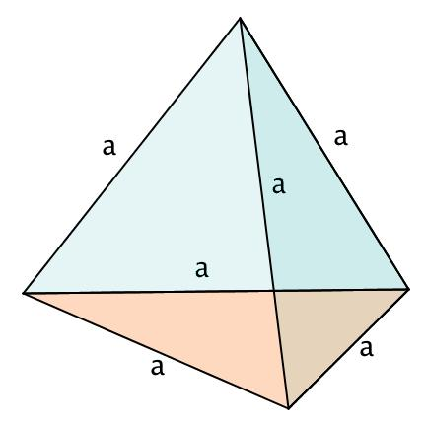
Tetrahedron
4 faces · 6 edges · 4 vertices
Has four triangular faces. A regular tetrahedron uses four equilateral triangles.
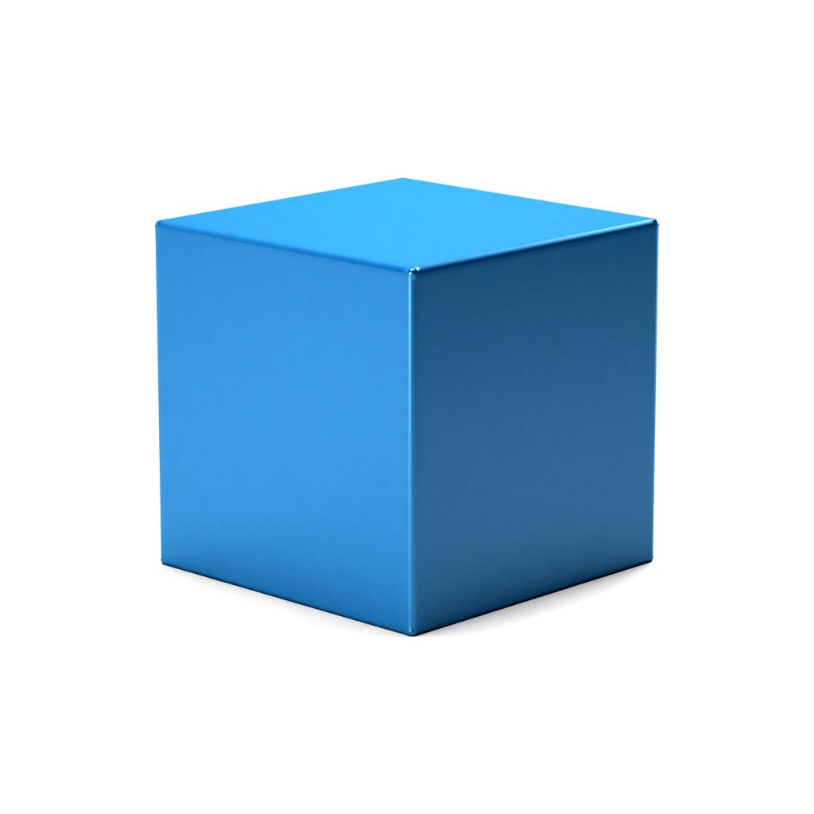
Cube (Hexahedron)
6 faces · 12 edges · 8 vertices
Has six square faces. It is another Platonic solid.
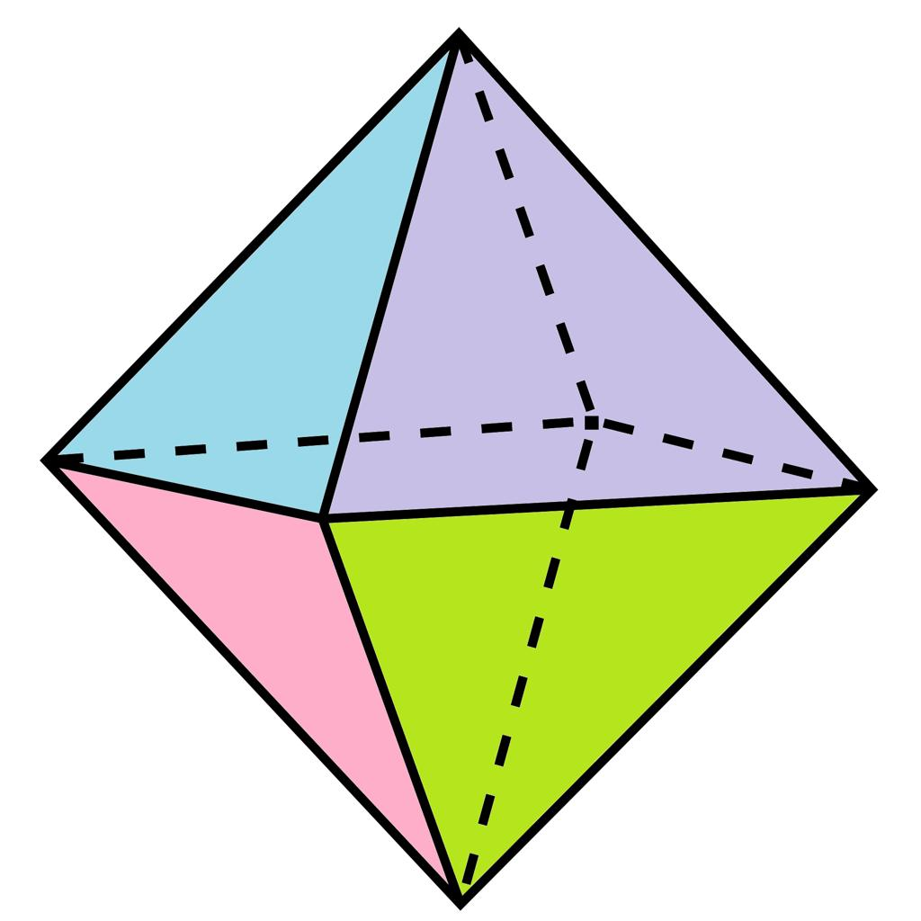
Octahedron
8 faces · 12 edges · 6 vertices
Has eight equilateral-triangle faces and is a Platonic solid.
A tetrahedron is also related to a triangular pyramid. The key distinction is that a regular tetrahedron must have four congruent equilateral-triangle faces, while a general triangular pyramid does not need to satisfy that condition.

The Tetrahedron Among the Five Platonic Solids
# Source: AI Source: Provided by: [Data Path: Persons Table -> ID Column: 1, Name_En Column: Motasem Essam] -> From: [ChatGPT] on [7/25/2026]
The five Platonic solids are:
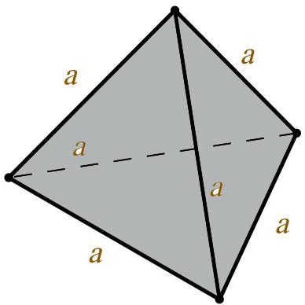
1. Tetrahedron
4 triangular faces
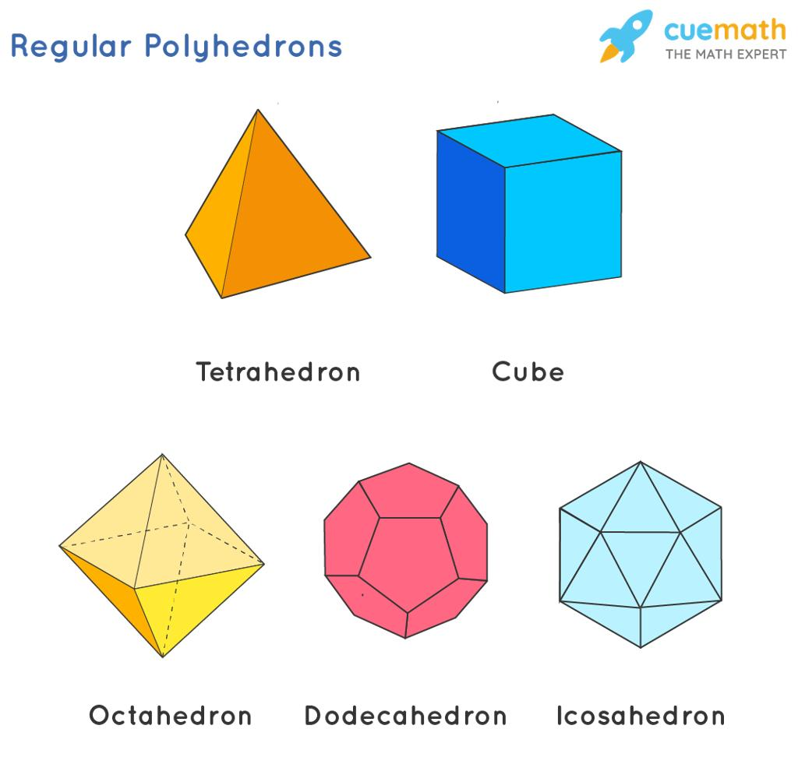
2. Cube (Hexahedron)
6 square faces
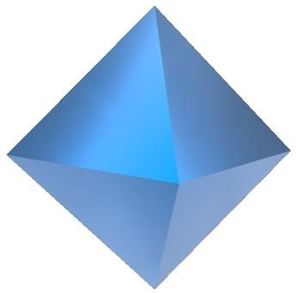
3. Octahedron
8 triangular faces
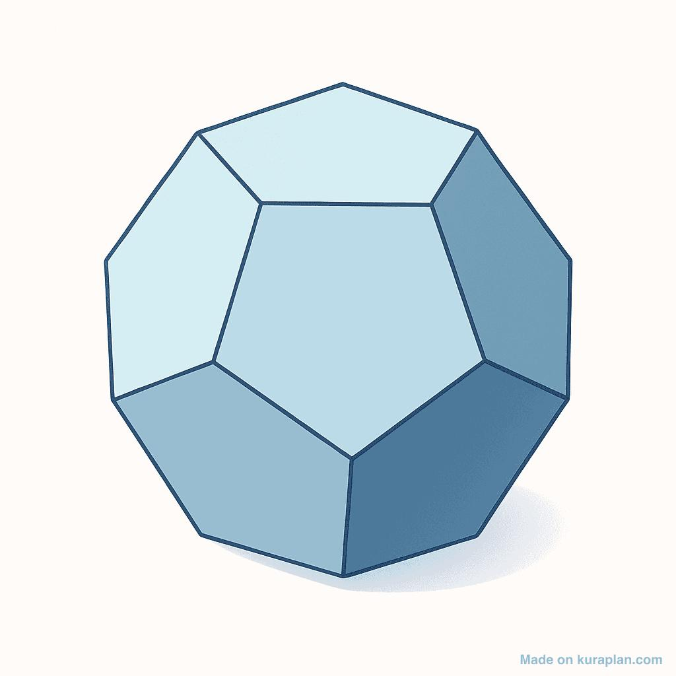
4. Dodecahedron
12 pentagonal faces
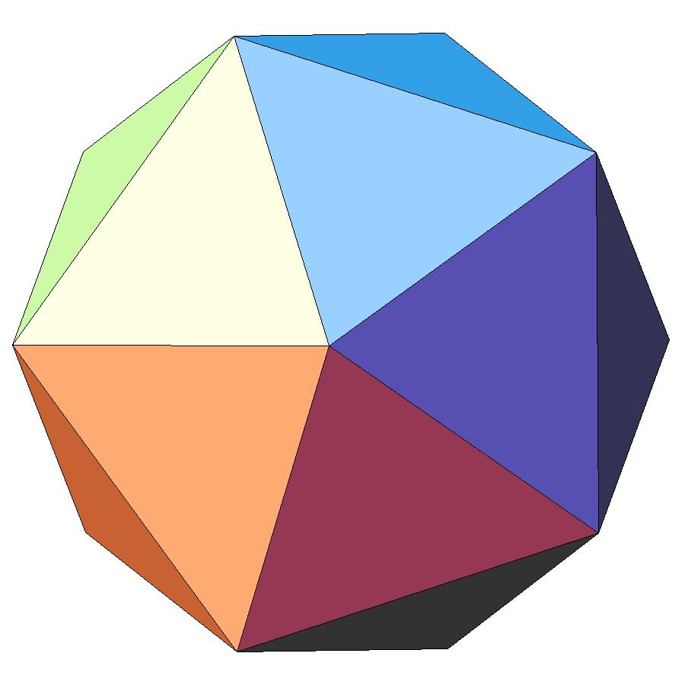
5. Icosahedron
20 triangular faces
All five have congruent regular polygonal faces, identical arrangements of faces around every vertex, and convex surfaces.

Constructing Tetrahedron in Solid Geometry

Instruments Used
# Source: AI Source: Provided by: [Data Path: Persons Table -> ID Column: 1, Name_En Column: Motasem Essam] -> From: [ChatGPT] on [7/25/2026]
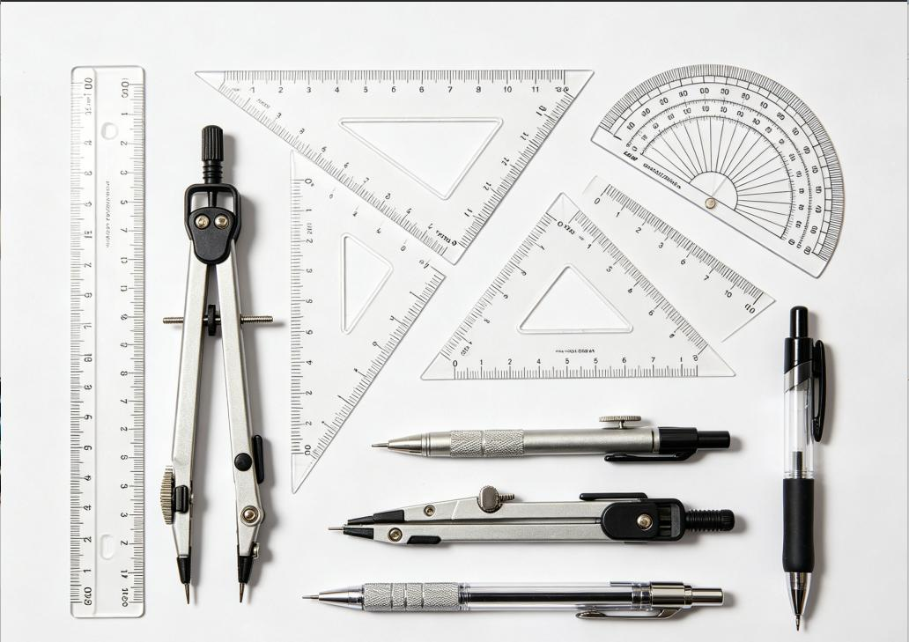
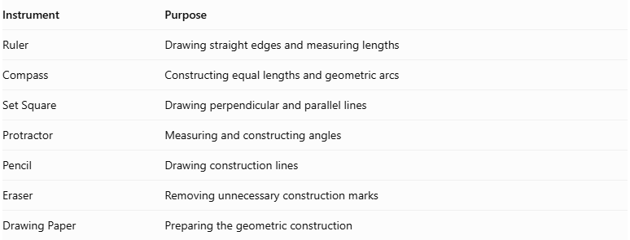
Instrument | Purpose
Ruler | Drawing straight edges and measuring lengths
Compass | Constructing equal lengths and geometric arcs
Set Square | Drawing perpendicular and parallel lines
Protractor | Measuring and constructing angles
Pencil | Drawing construction lines
Eraser | Removing unnecessary construction marks
Drawing Paper | Preparing the geometric construction
Construction Method: Instrument-Based

Construction Procedures

Constructing an Equilateral Triangular Base
# Source: AI Source: Provided by: [Data Path: Persons Table -> ID Column: 1, Name_En Column: Motasem Essam] -> From: [ChatGPT] on [7/25/2026]
- Draw a straight line representing one side of the triangular base.
- Set the compass to the length of the side.
- Draw an arc from each endpoint.
- Mark the intersection of the two arcs.
- Connect the intersection to both endpoints.
- Verify that all three sides are equal.

Constructing a Regular Tetrahedron
# Source: AI Source: Provided by: [Data Path: Persons Table -> ID Column: 1, Name_En Column: Motasem Essam] -> From: [ChatGPT] on [7/25/2026]
- Construct an equilateral triangular base.
- Draw the medians of the triangle to locate its center.
- Draw a perpendicular line through the center of the base.
- Determine the required tetrahedron height.
- Mark the apex on the perpendicular line.
- Connect the apex to all three base vertices.
- Draw visible edges using solid lines.
- Draw hidden edges using dashed lines where appropriate.
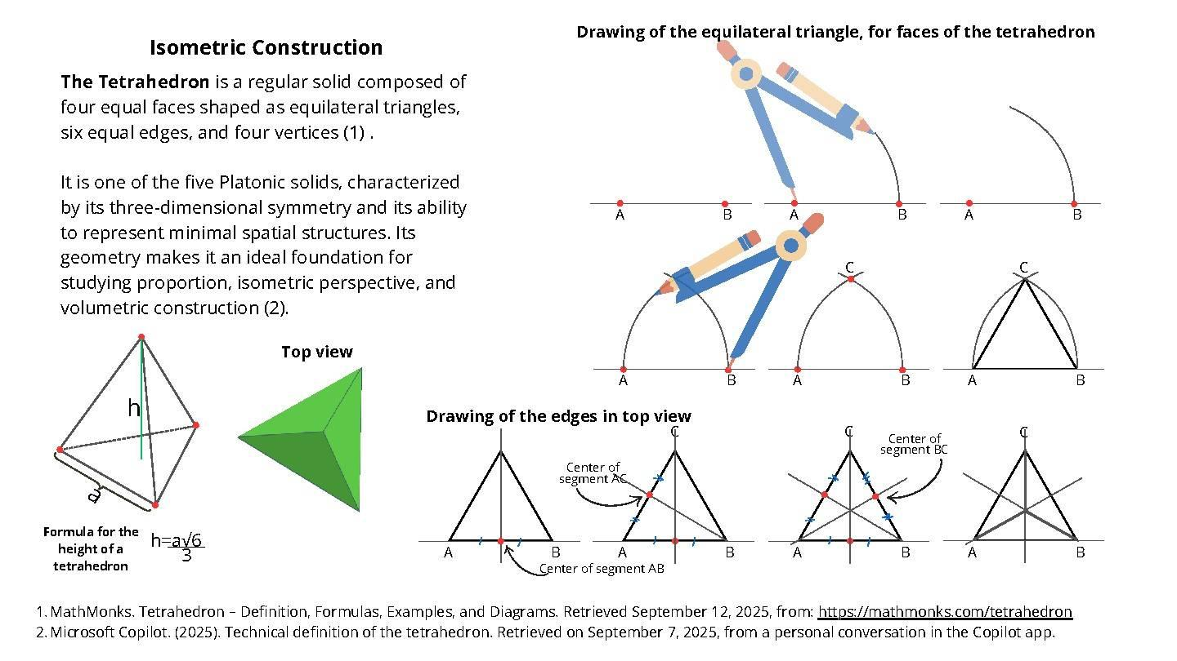
For a regular tetrahedron with edge length $a$, the required height is:
$$h=a\sqrt{\frac{2}{3}}$$

Constructing an Irregular Tetrahedron
# Source: AI Source: Provided by: [Data Path: Persons Table -> ID Column: 1, Name_En Column: Motasem Essam] -> From: [ChatGPT] on [7/25/2026]
- Construct a triangular base using the desired side lengths and angles.
- Select the position of the apex above the base plane.
- Determine the desired distances from the apex to the three base vertices.
- Connect the apex to all three base vertices.
- Complete the four triangular faces.
- Distinguish visible and hidden edges.
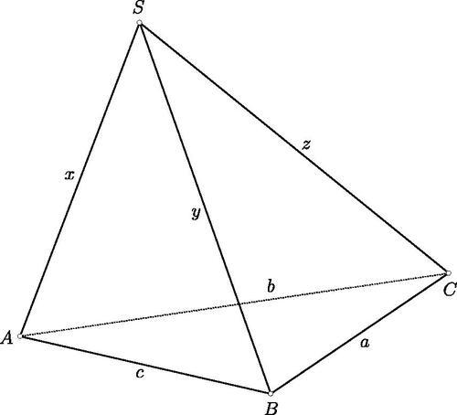

Constructing a Tetrahedron Using Face-Based Construction
# Source: AI Source: Provided by: [Data Path: Persons Table -> ID Column: 1, Name_En Column: Motasem Essam] -> From: [ChatGPT] on [7/25/2026]
- Draw one triangular face.
- Construct a second triangular face sharing one edge with the first.
- Construct a third triangular face sharing another appropriate edge.
- Complete the final triangular face by connecting the remaining boundary edges.
- Verify that the resulting solid has four triangular faces.

Constructing the Net of a Tetrahedron
# Source: AI Source: Provided by: [Data Path: Persons Table -> ID Column: 1, Name_En Column: Motasem Essam] -> From: [ChatGPT] on [7/25/2026]
- Draw an equilateral triangle representing the base.
- Attach three congruent equilateral triangles to its three sides.
- Ensure that all triangles have equal side lengths.
- Add joining flaps if the net is intended for physical assembly.
- Cut and fold the net to form a regular tetrahedron.
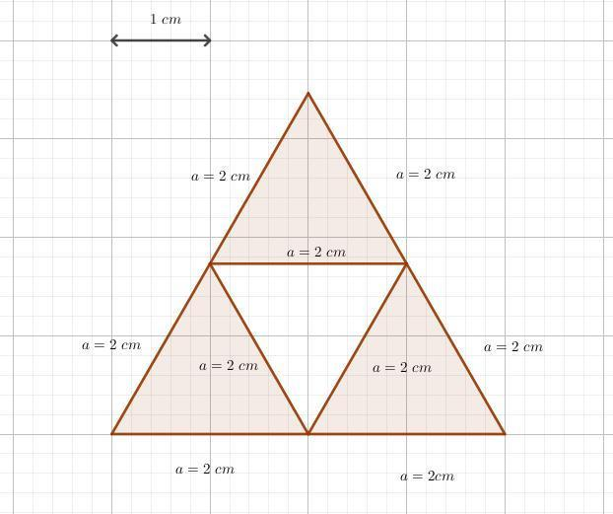

Applications of the Tetrahedron
# Source: AI Source: Provided by: [Data Path: Persons Table -> ID Column: 1, Name_En Column: Motasem Essam] -> From: [ChatGPT] on [7/25/2026]
- Architecture and engineering: tetrahedral frameworks can provide structural rigidity.
- Chemistry: the tetrahedral arrangement describes the geometry around certain atoms, such as the carbon atom in methane.
- Games and probability: four-sided dice are commonly shaped like tetrahedra.
- Computer graphics: tetrahedra are used in 3D mesh generation and volume modeling.
- Mathematics: the tetrahedron is a fundamental example of a polyhedron and a triangular pyramid.

Key Points
# Source: AI Source: Provided by: [Data Path: Persons Table -> ID Column: 1, Name_En Column: Motasem Essam] -> From: [ChatGPT] on [7/25/2026]
- A tetrahedron is a triangular pyramid with four faces.
- A regular tetrahedron is one of the five Platonic solids.
- Its four faces are equilateral triangles.
- It has 4 faces, 6 edges, and 4 vertices.
- Its total surface area is $A_{T}=\sqrt{3}a^{2}$.
- Its volume is $V=\frac{\sqrt{2}}{12}a^{3}$.
- Its perpendicular height is $h=a\sqrt{\frac{2}{3}}$.
- Its geometry satisfies Euler's formula: $V_{e}-E+F=2$.

Conclusion
# Source: AI Source: Provided by: [Data Path: Persons Table -> ID Column: 1, Name_En Column: Motasem Essam] -> From: [ChatGPT] on [7/25/2026]
The tetrahedron is the simplest Platonic solid and an important three-dimensional geometric figure. Its four congruent equilateral-triangle faces, six equal edges, and four vertices make it a fundamental example for studying polyhedra, pyramids, surface area, volume, and symmetry. Understanding the tetrahedron also provides a foundation for learning about the other four Platonic solids.

